**Codecommit with Jenkins integartion for evry change in code commit repo**

1. I have created one code commit repo in aws server

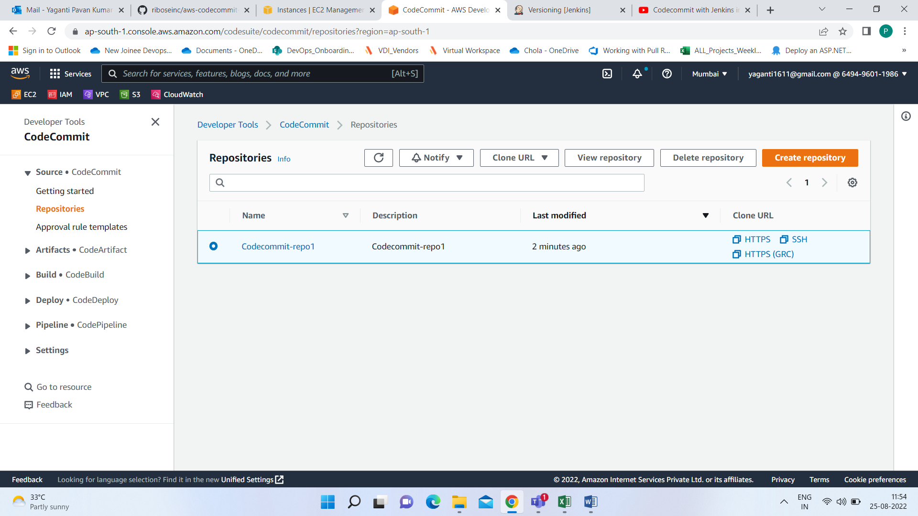

1. And created one SNS topic



3.Created one amazon SQS in aws console

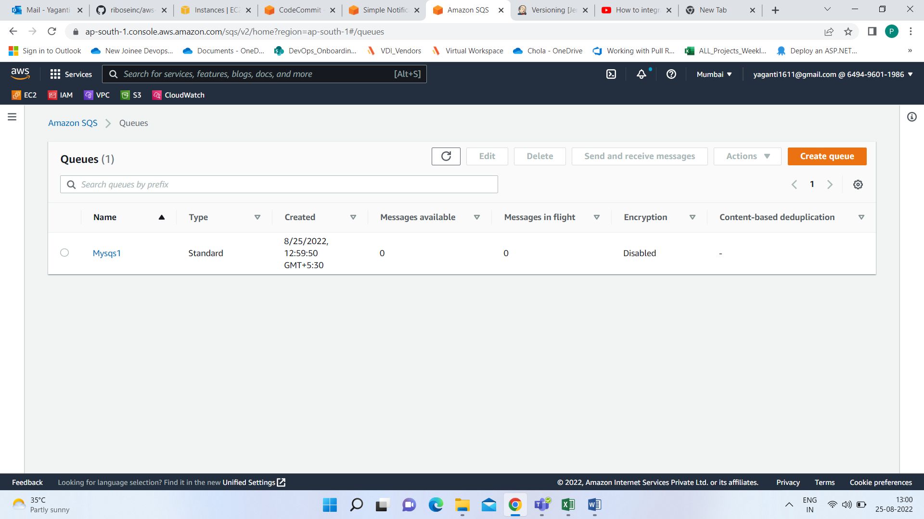

1. Open the SQS queue, do queue actions to subscribe it to SNS Topic

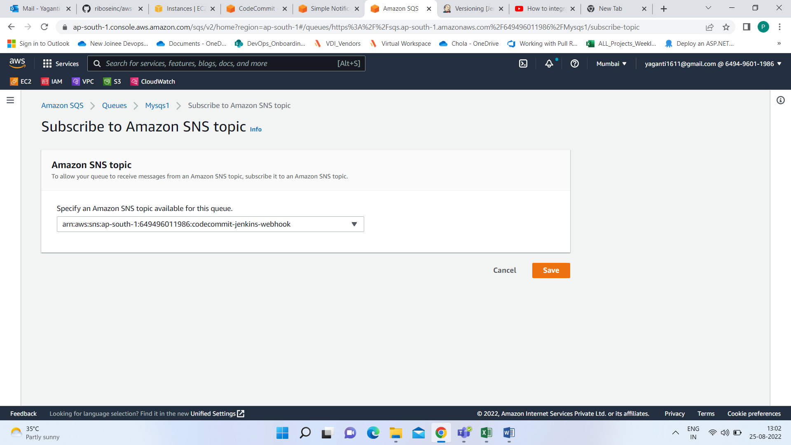

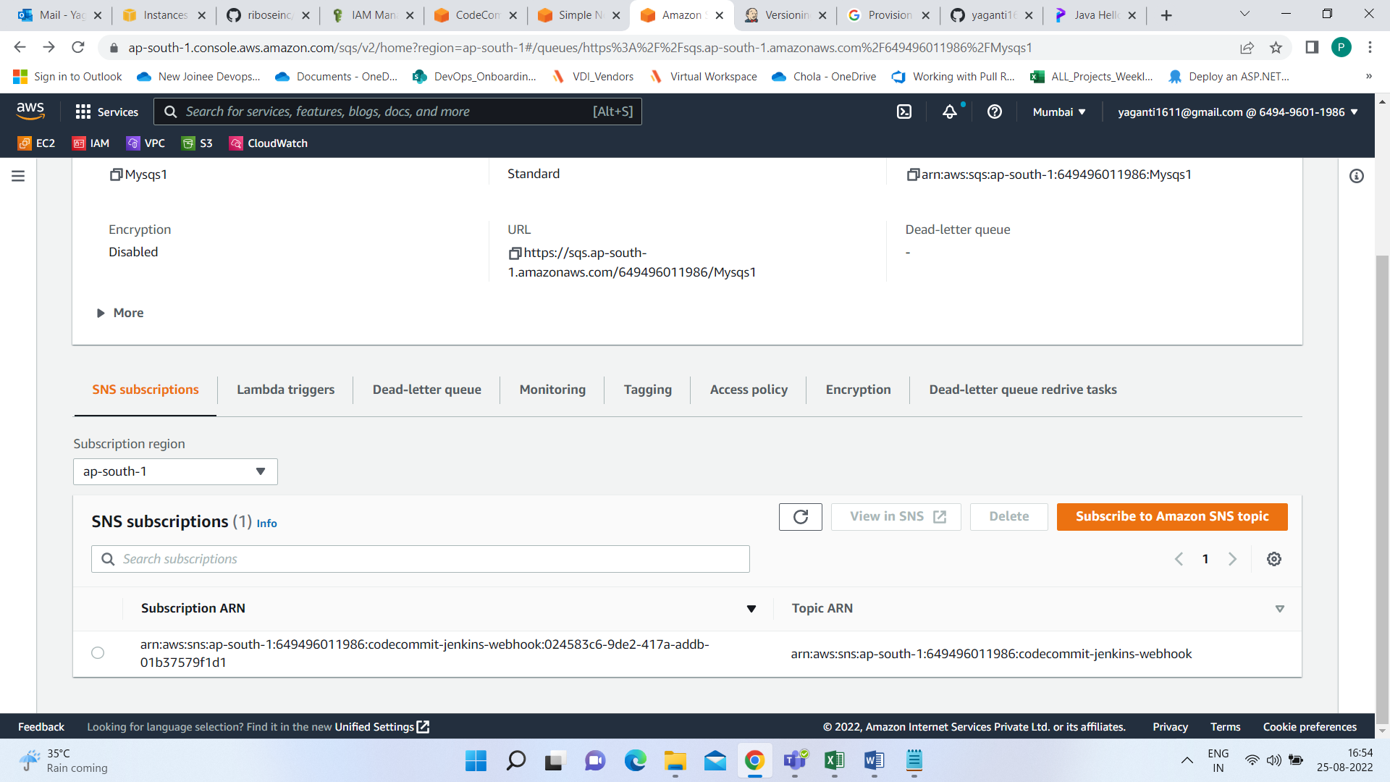

1. Make sure the AWS Credentials used for this Plugin has Permission to

Here below we can see the My user access

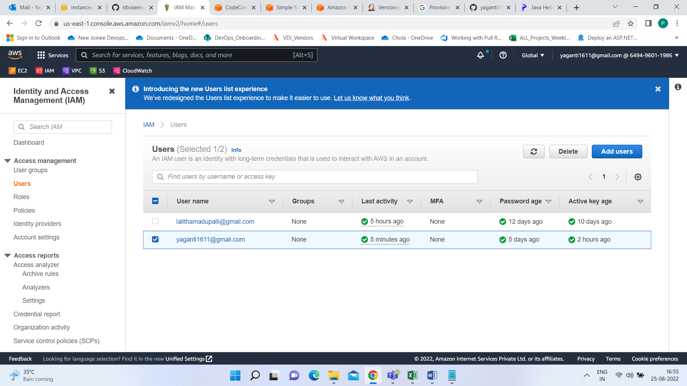

To this user access I have mentioned the specific role for sqs plugin

* sqs:ReceiveMessage
* sqs:DeleteMessage
* sqs:DeleteMessageBatch
* sqs:GetQueueAttributes
* sqs:ListQueues (optional)

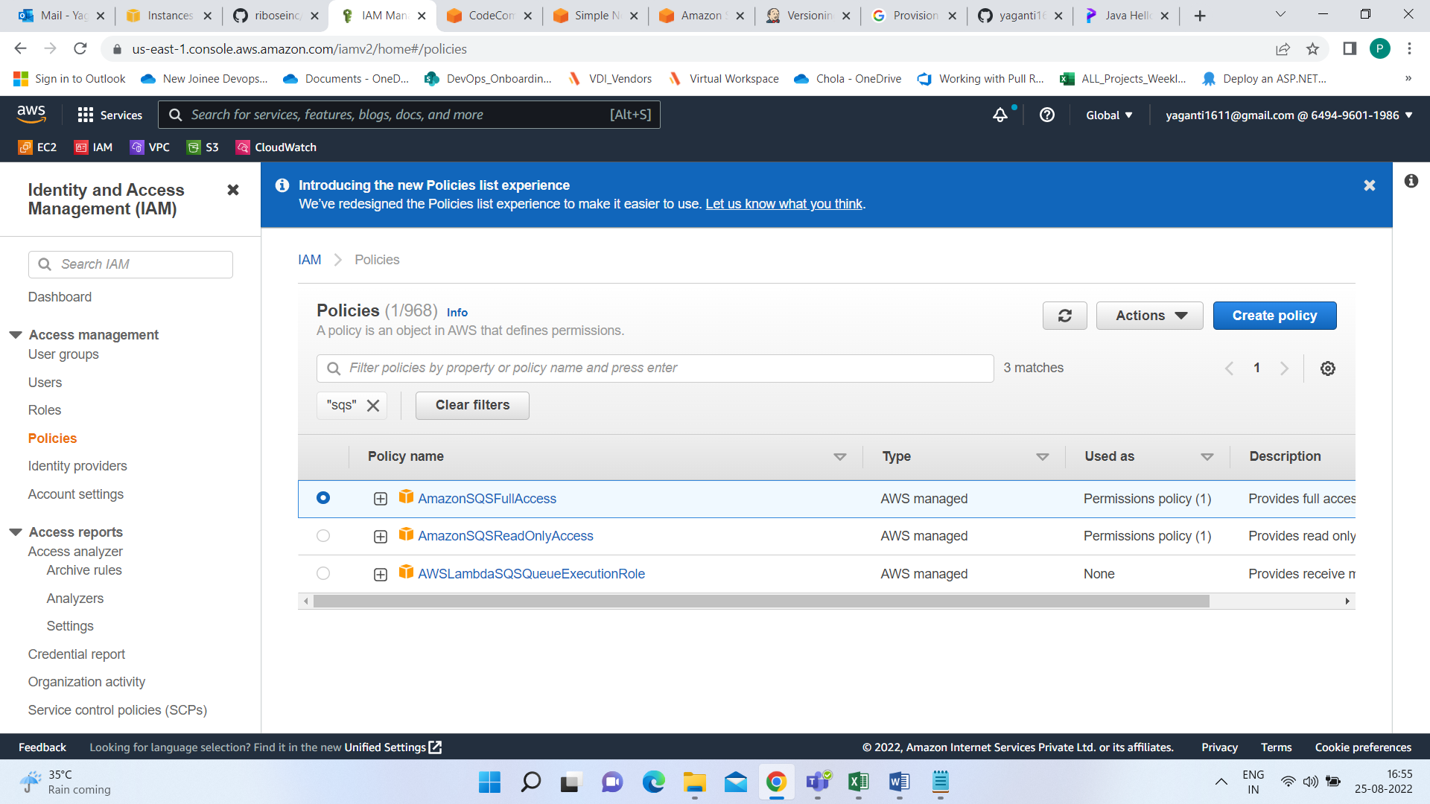

1. Go to Jenkins > Manage Jenkins > Configure System on your Jenkins
2. Go to AWS Code Commit Trigger SQS Plugin
3. Configure a queue
   * Select the name of the queue you just created (the list auto-loaded using selected AWS Credentials)
   * Select "Aws Credentials" from the list or click on button "Add Credentials" to create one
   * Access Key ID and Secret Access Key is setup using [AWS Credentials](https://plugins.jenkins.io/aws-credential)

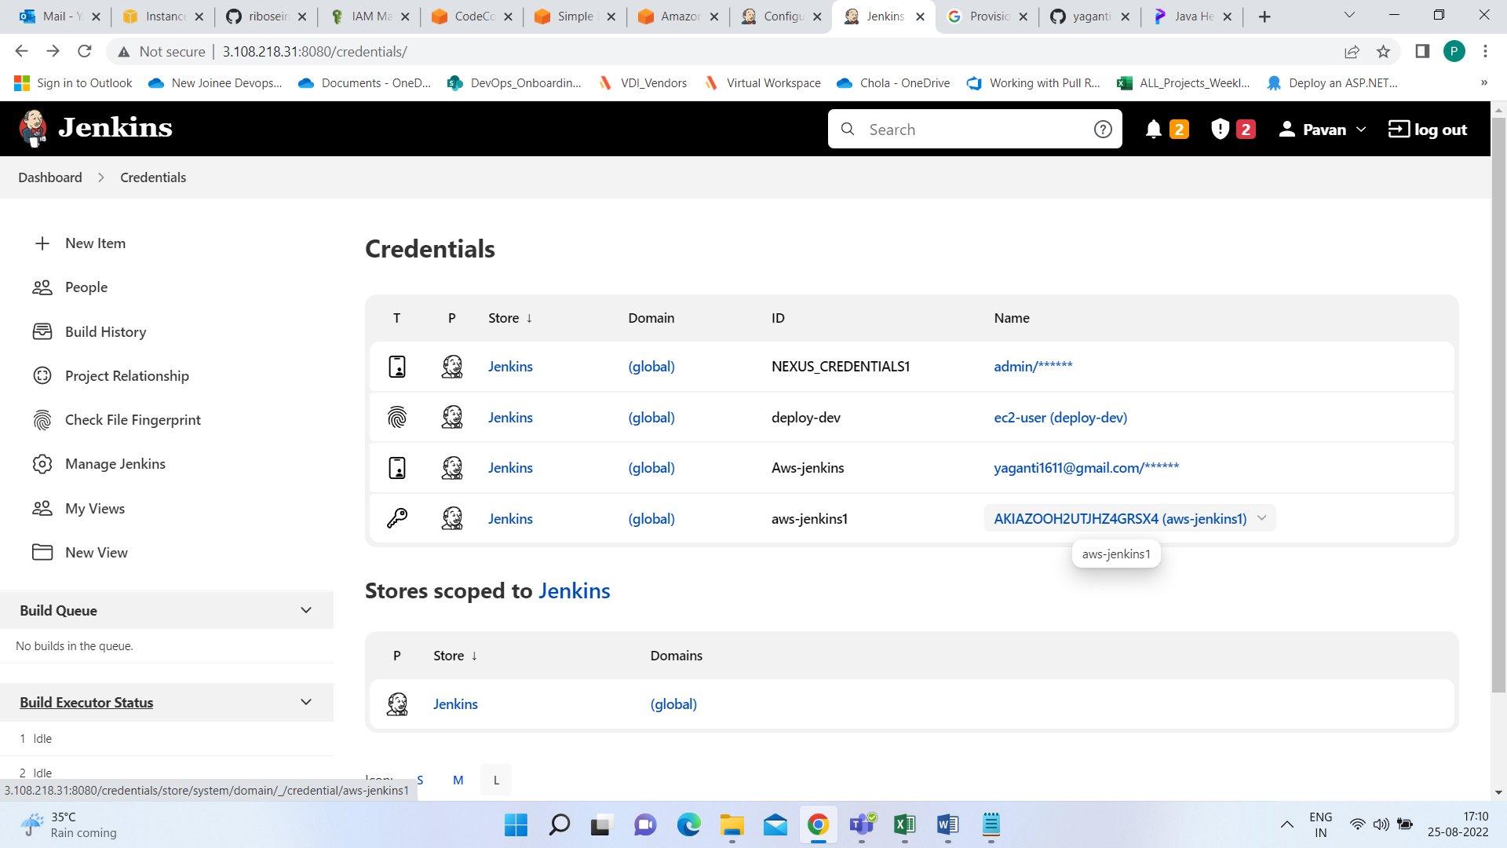

* + **NOT** support for IAM Roles and IAM MFA Token

1. Click on **Test access**
2. You should see a success message.

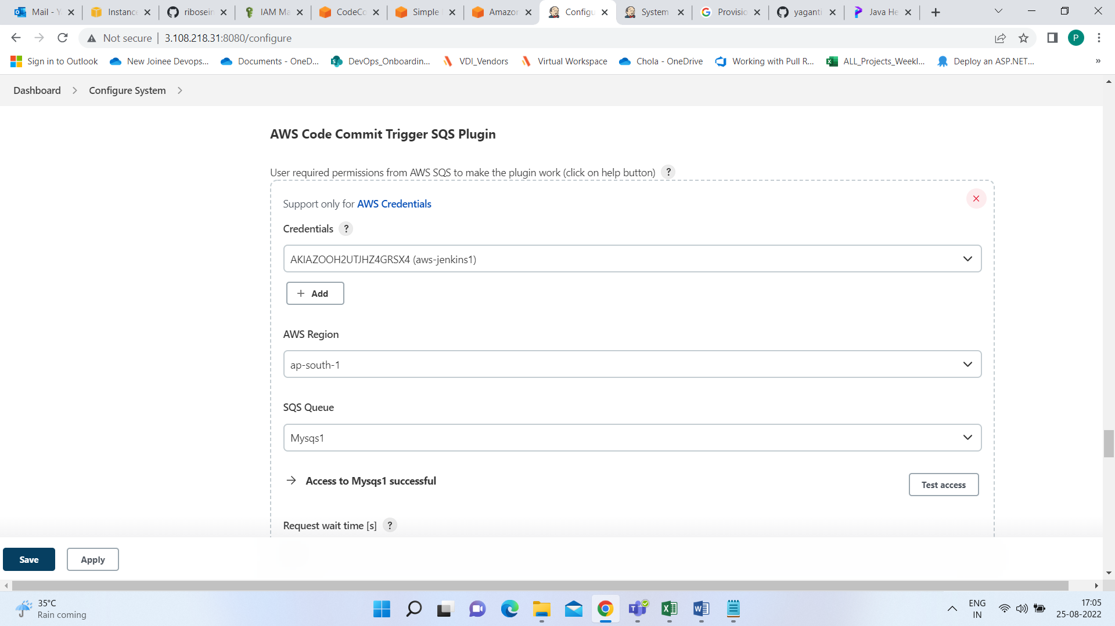

Configuration sample

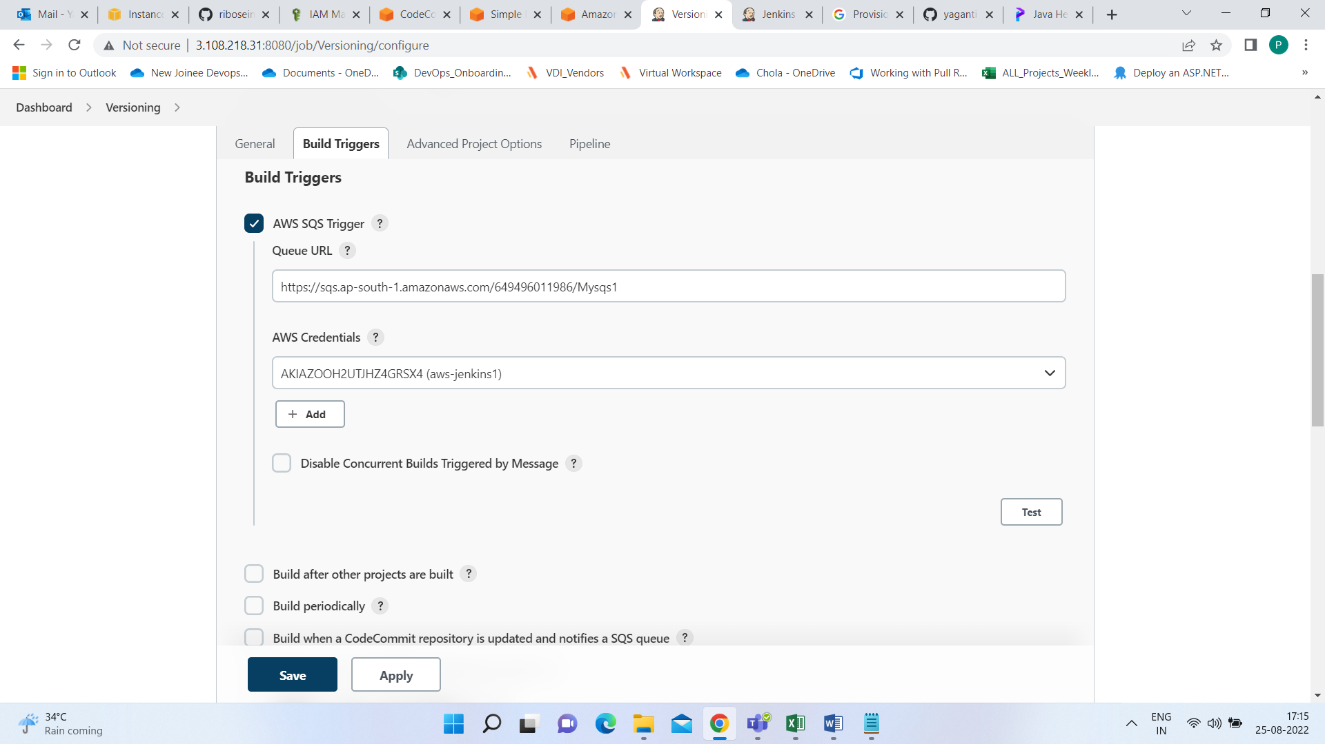

Here I did some modifications in code and saved

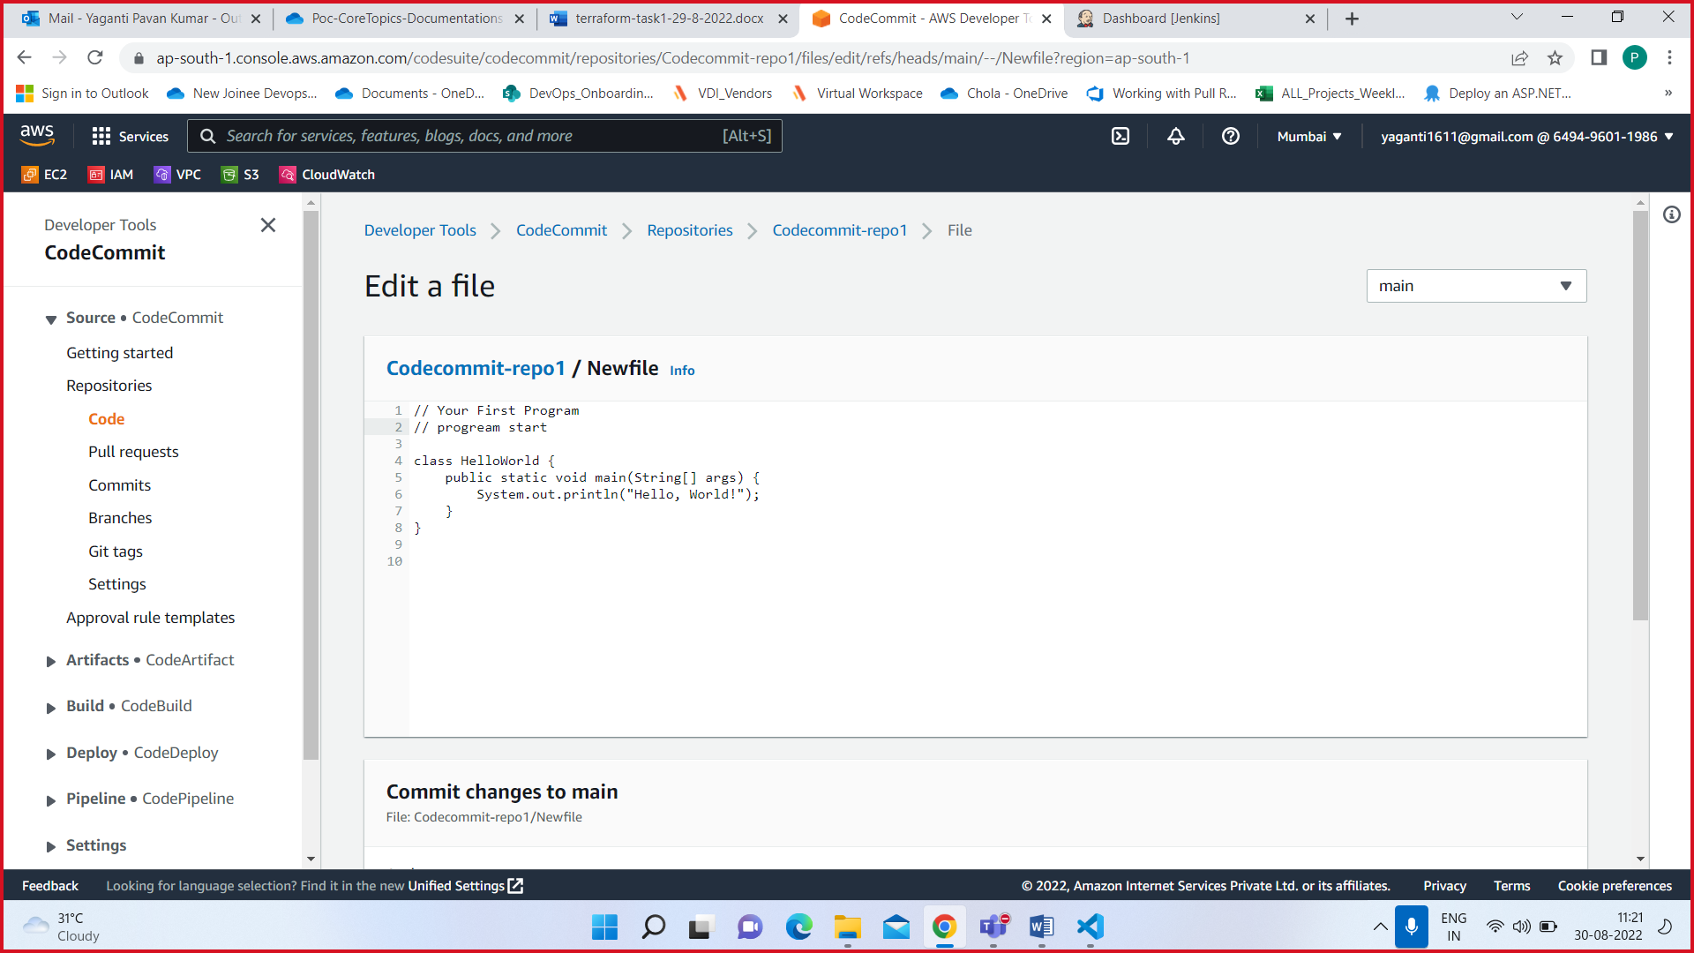

If you see here one commit id after change the code

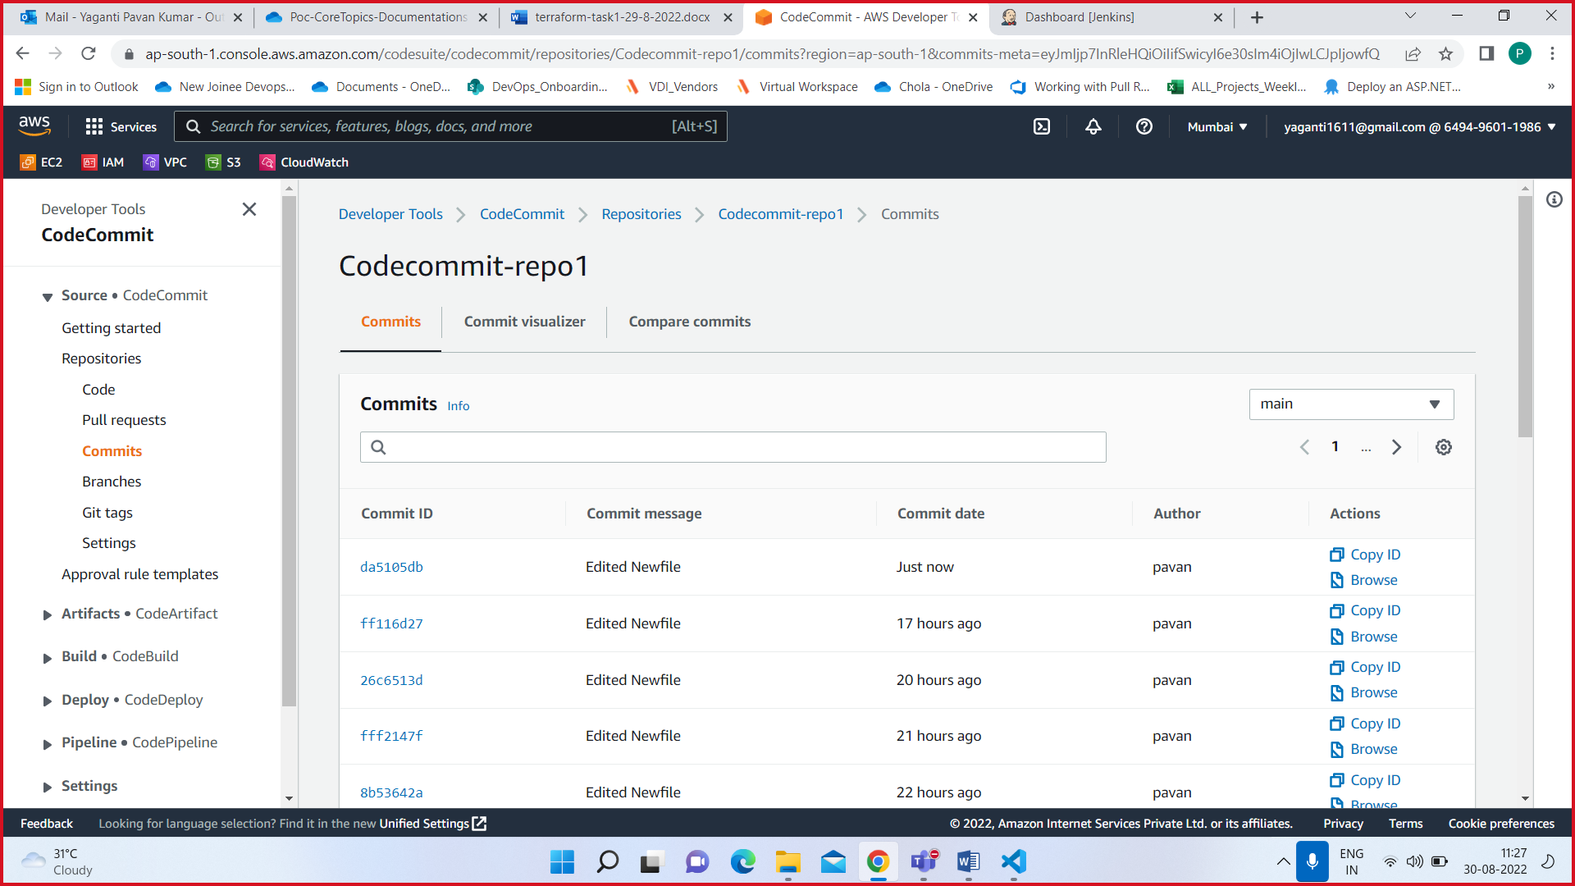

Whenever the developer can make a commit in code repo the Jenkins pipeline is automatically triggered.

